**Task-1 Creation of S3 Bucket**

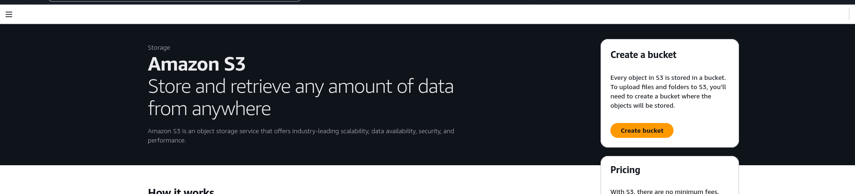

Create the S3 bucket and upload the object into it   
  
i) Change the bucket level permissions   
ii) Change the object level permissions   
iii) Make the bucket publicly accessible   
  
Note:- Upload the document with i) URL of object ii) Screenshots of each and every step

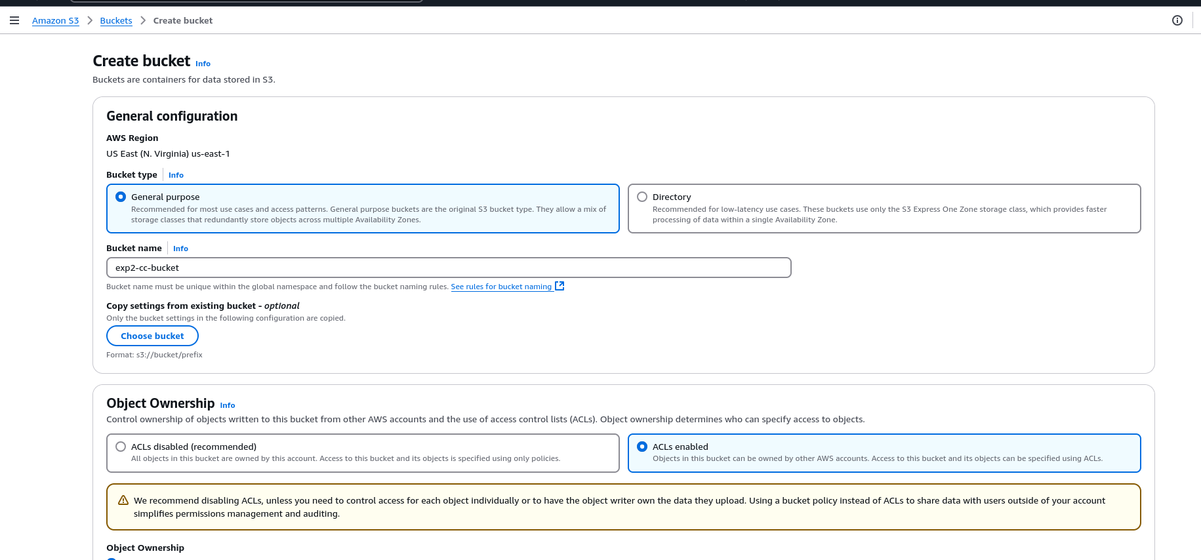

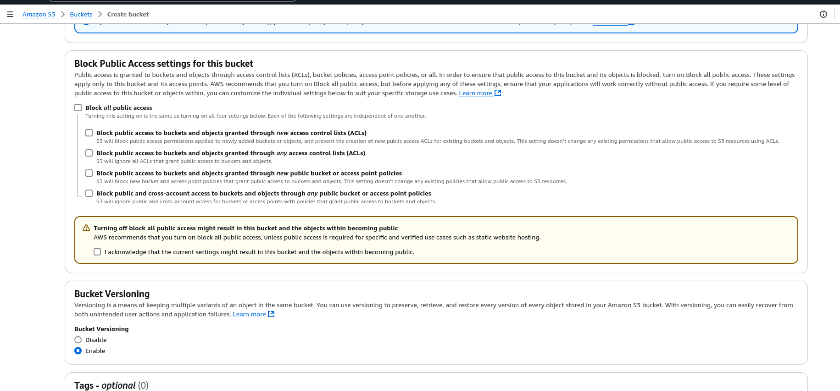

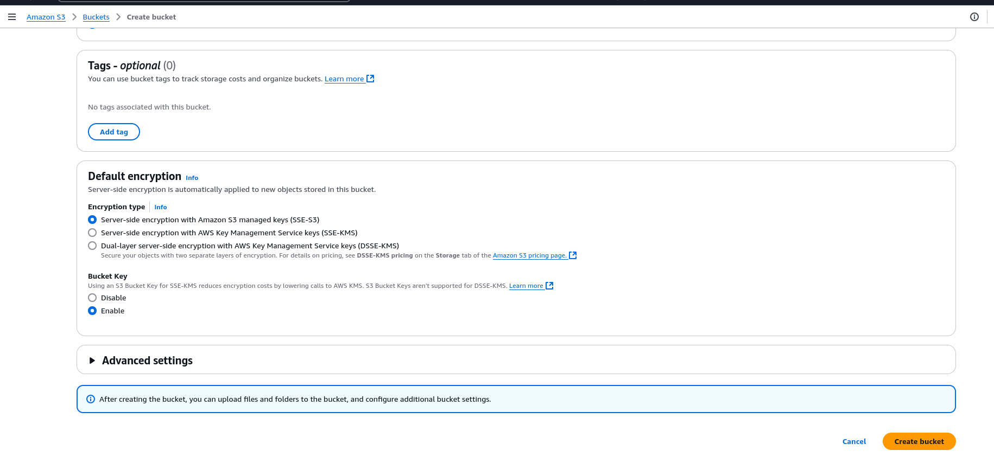

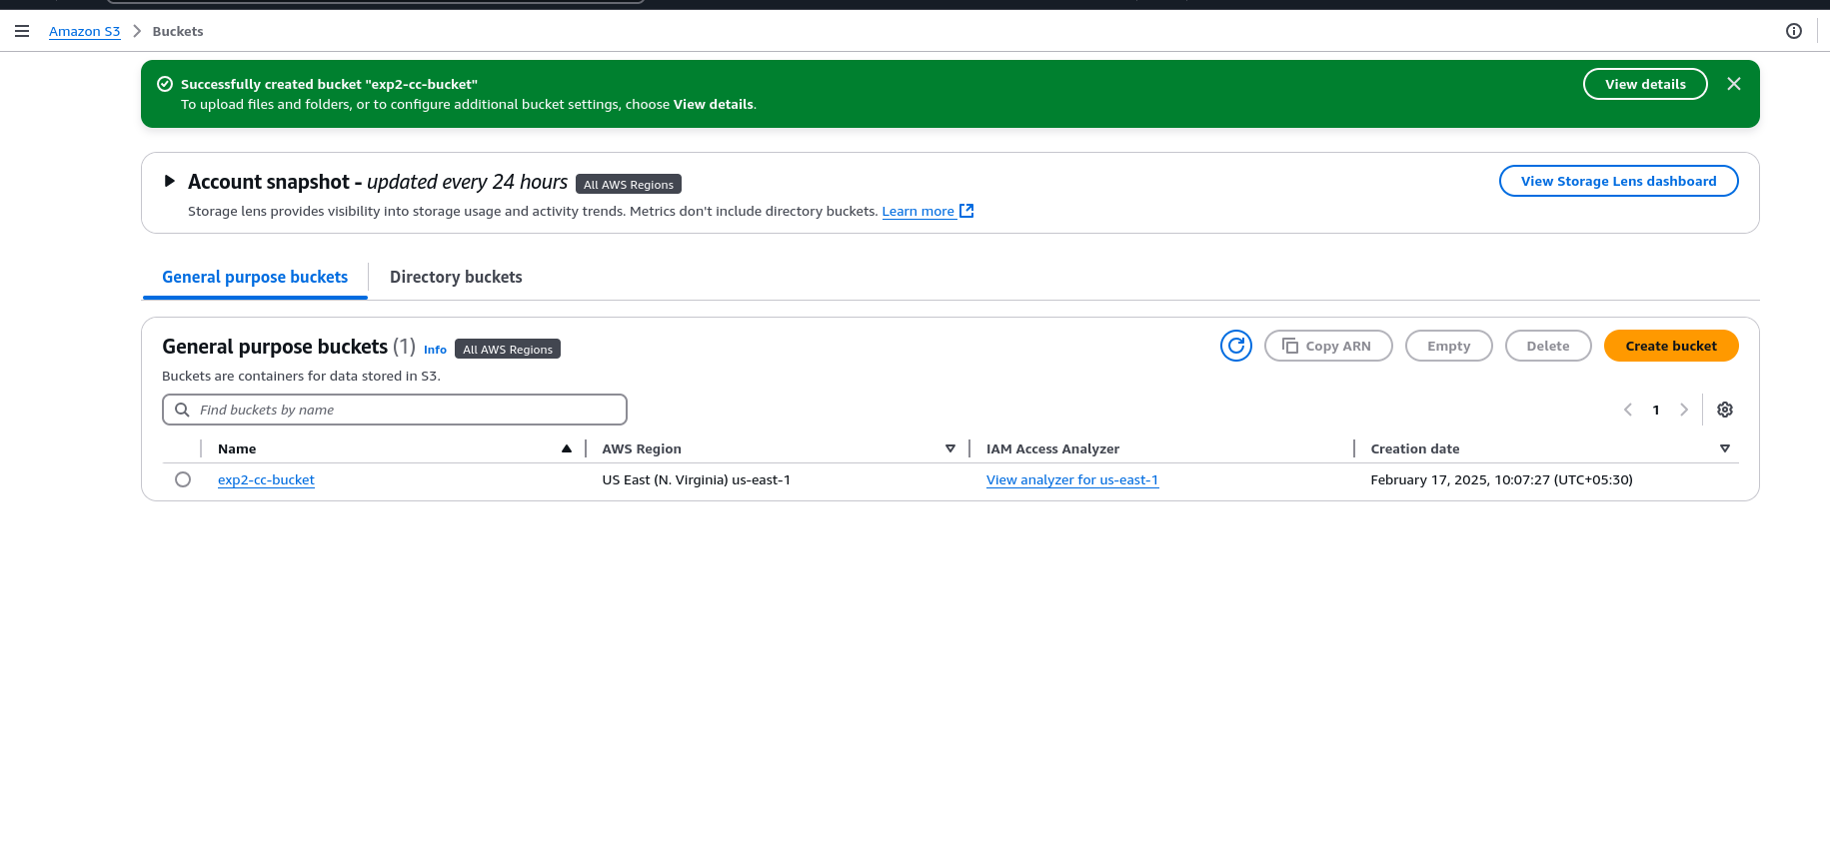

Click on upload

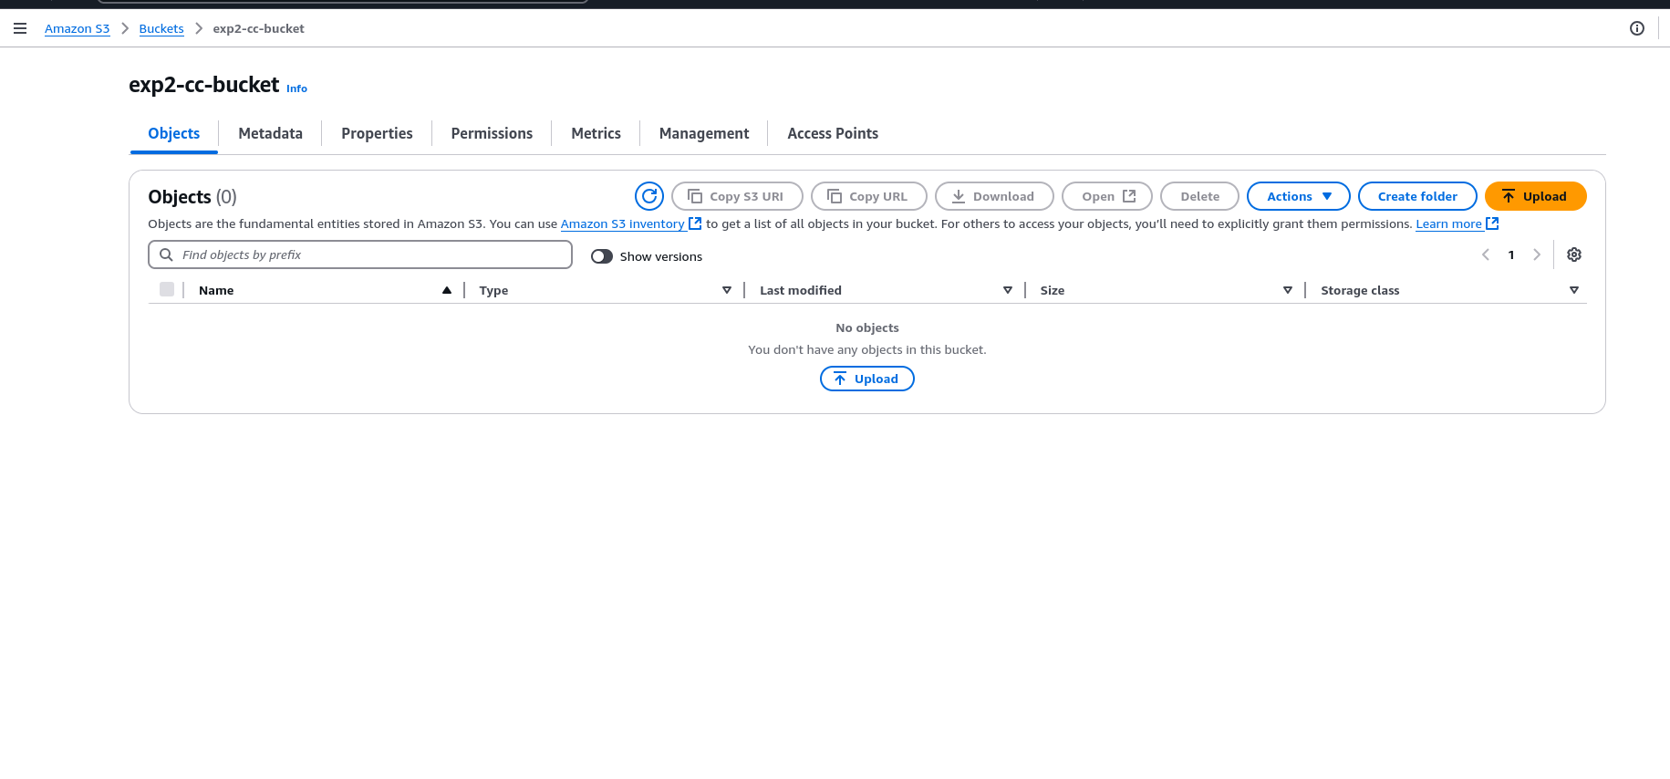

Click on Add files

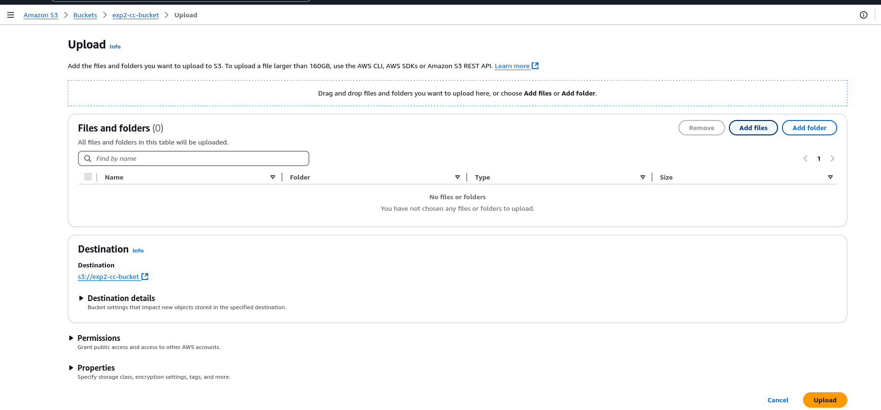

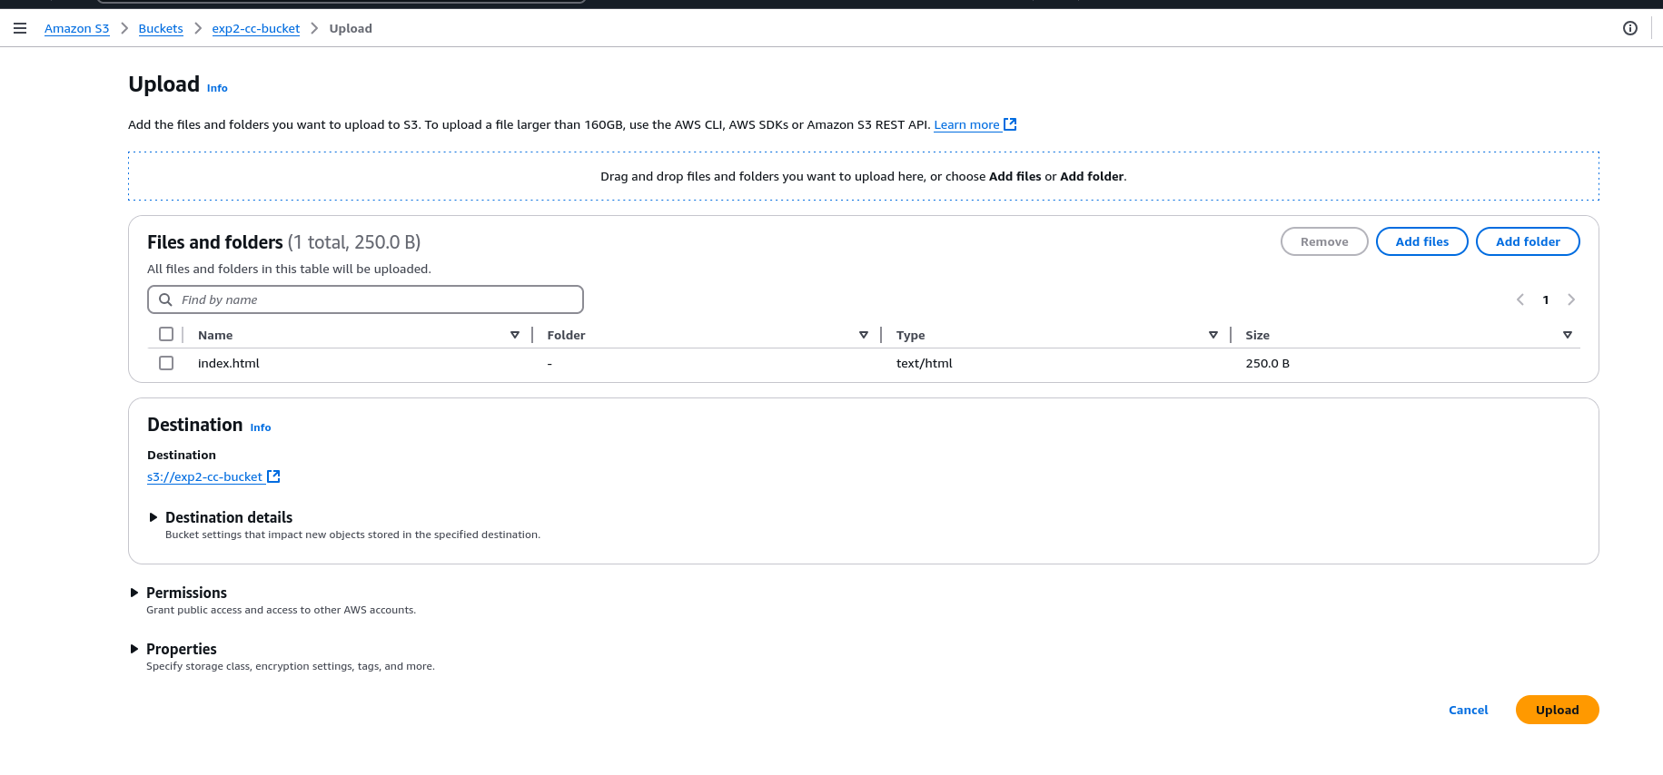

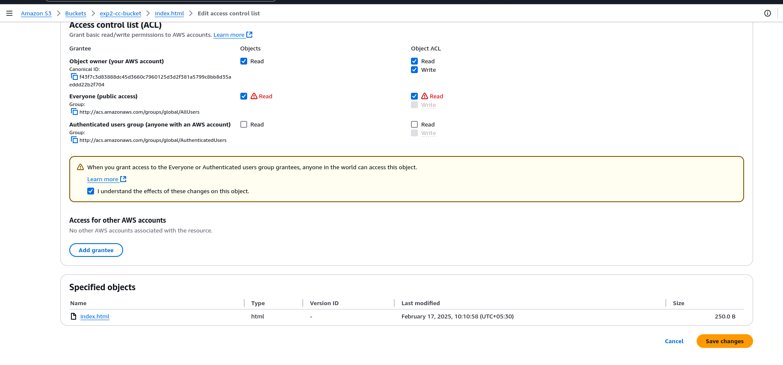Set proper permissions to manage access

HTML File Output:- <https://exp2-cc-bucket.s3.us-east-1.amazonaws.com/index.html>

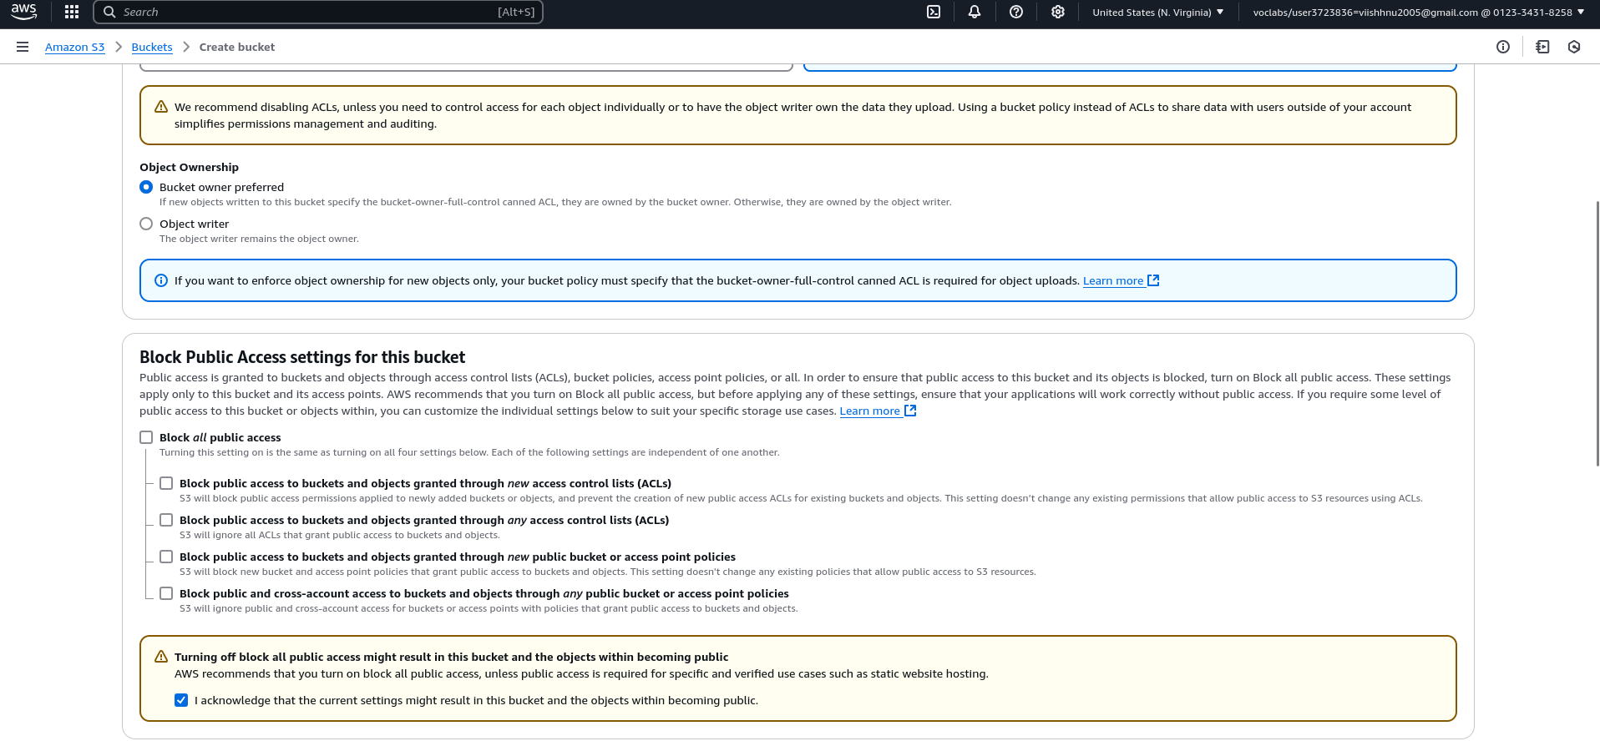

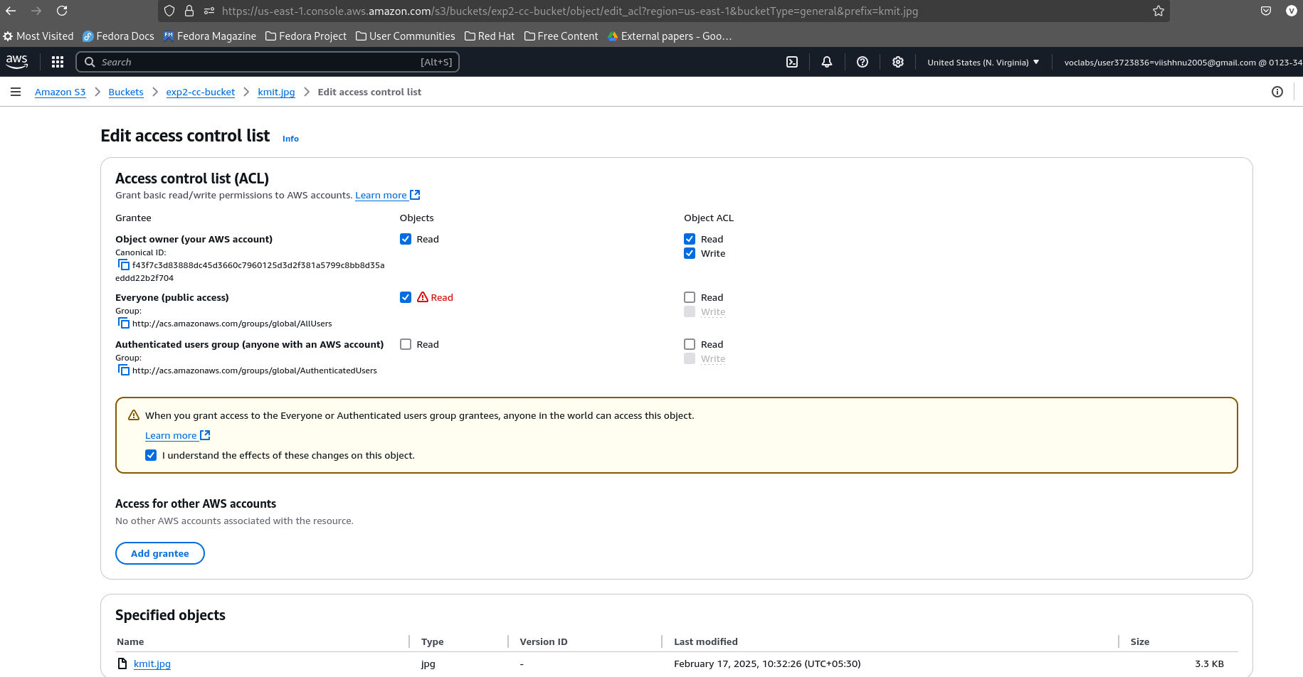

Image:- https://exp2-cc-bucket.s3.us-east-1.amazonaws.com/kmit.jpg

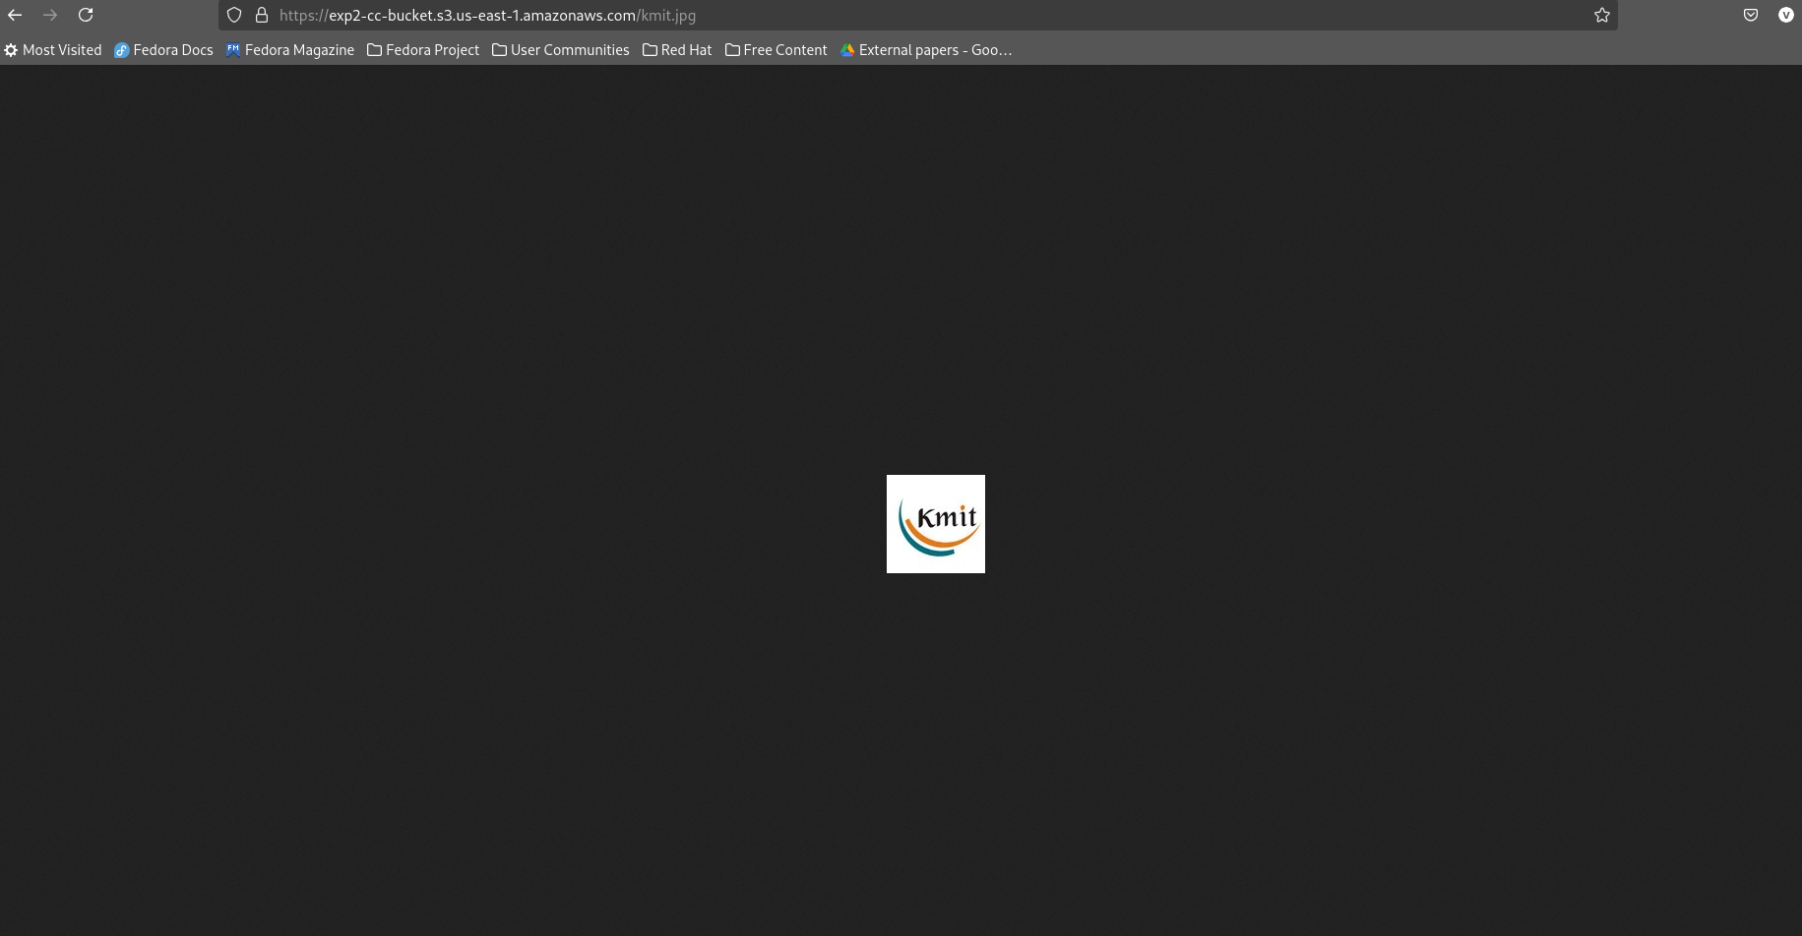

PDF [File:-](../../../../../-) https://exp2-cc-bucket.s3.us-east-1.amazonaws.com/3-2+syllabus.pdf

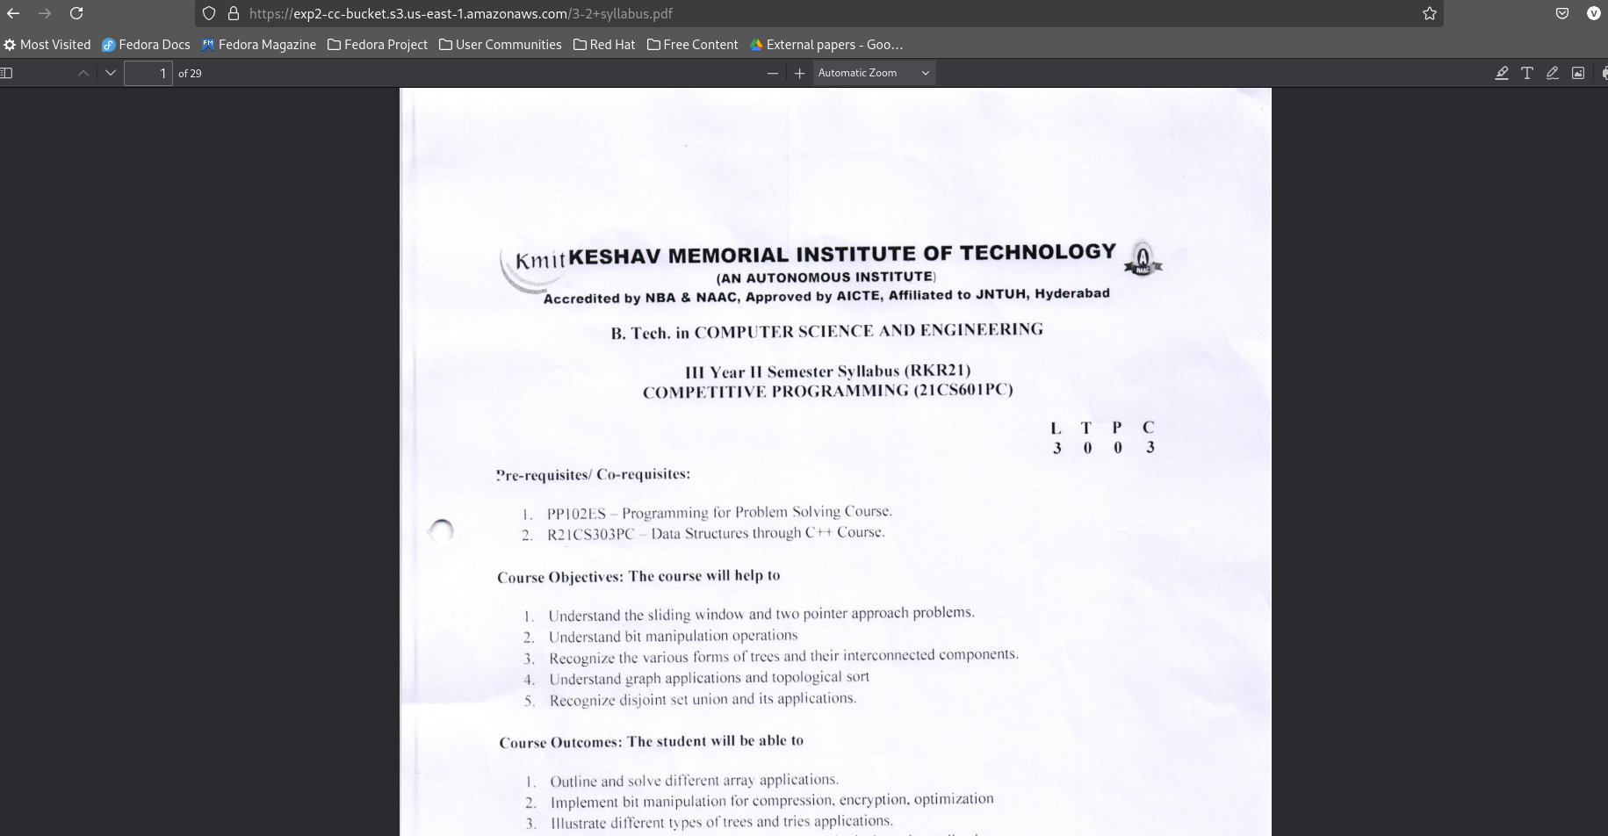

### ****Task-2:- Set Cross-Region Replication (CRR) for S3****

Cross-Region Replication (CRR) ensures automatic copying of objects between AWS regions.

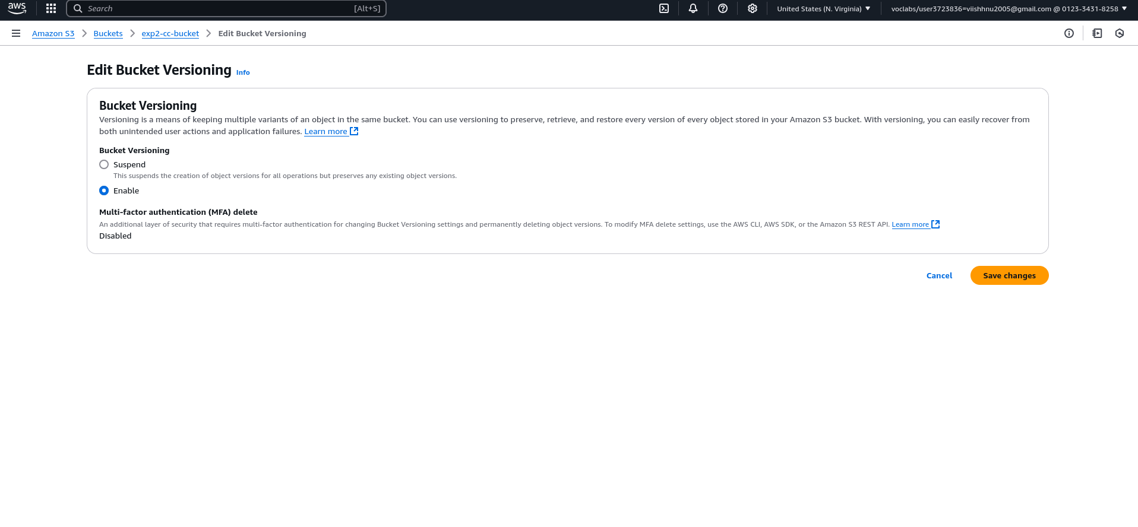

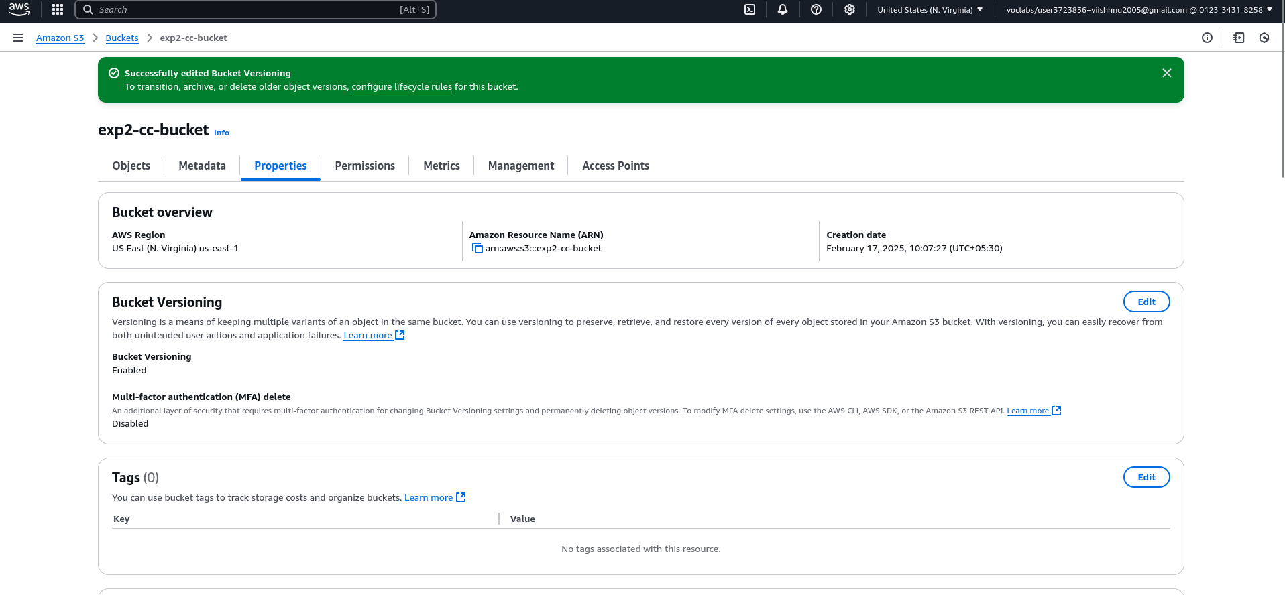

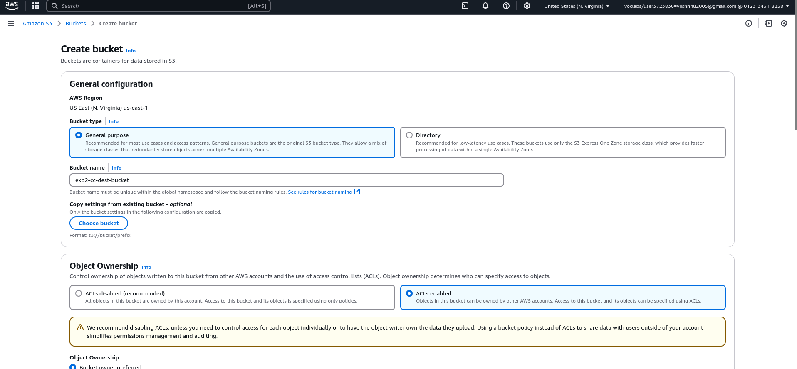



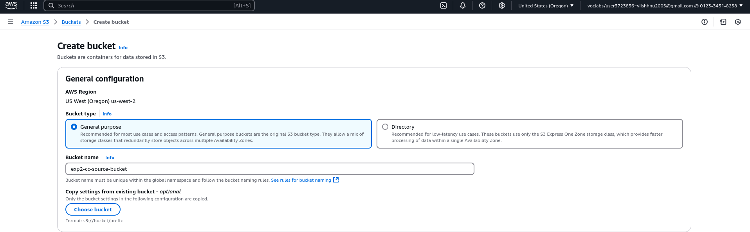

Create a source bucket

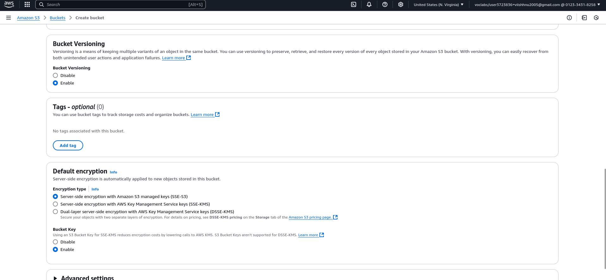

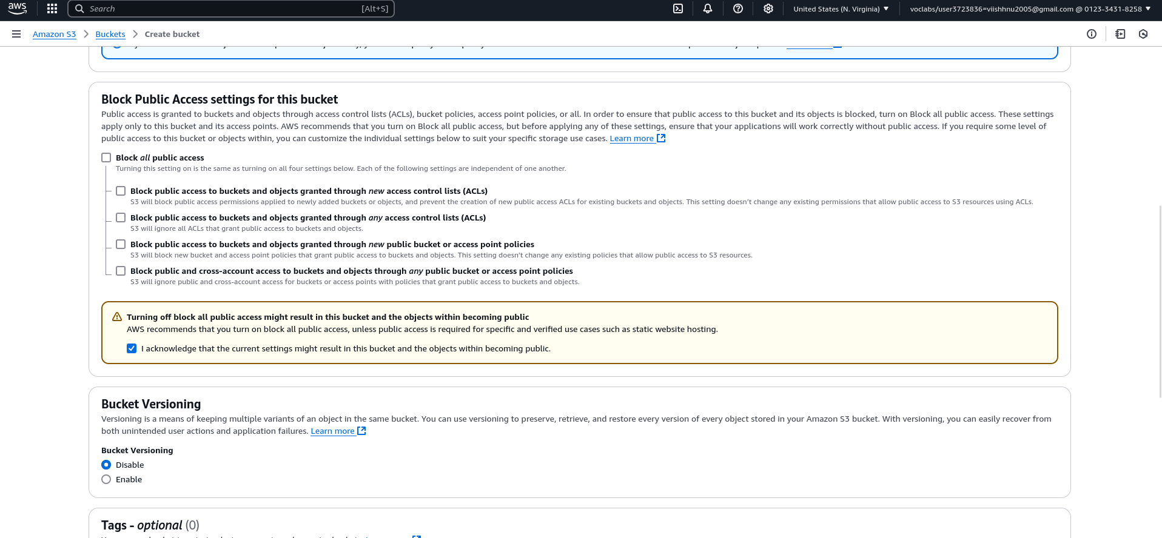

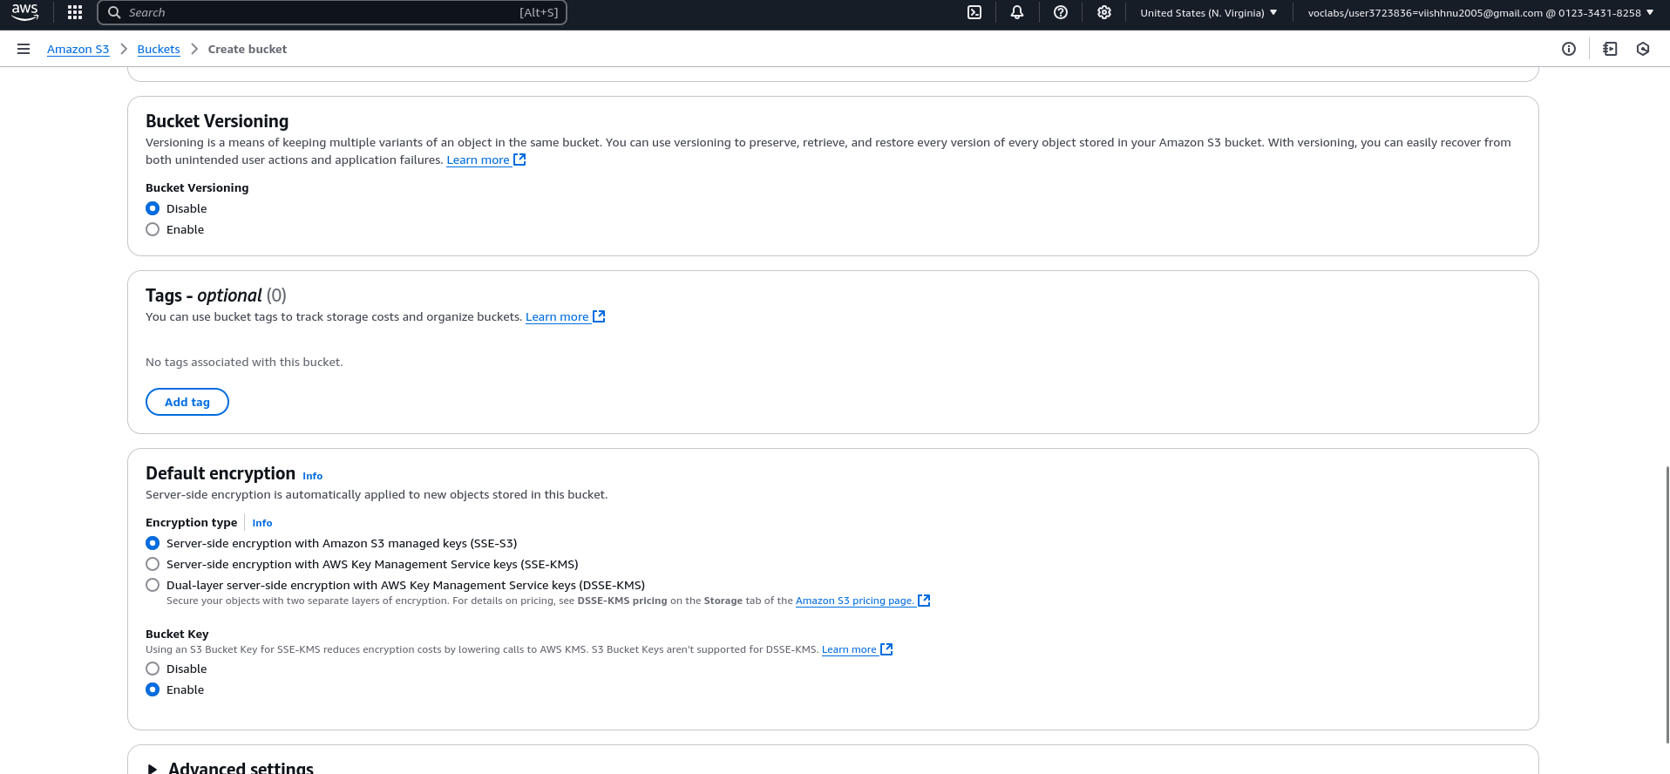

**Select the Source Bucket:**

Click on the bucket you want to replicate.

**Set Up Replication:**

Click on **Replication rules** → **Create replication rule**.

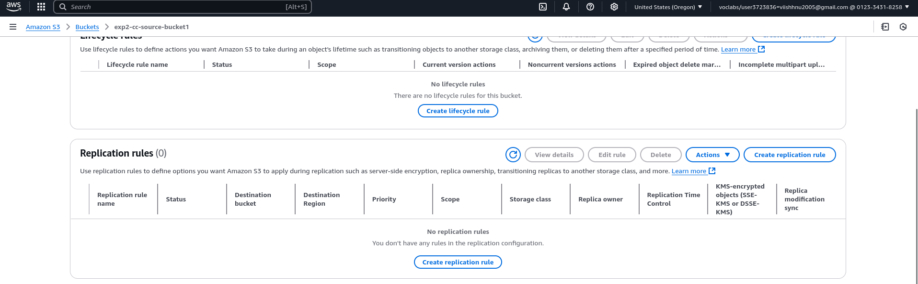

Name the replication rule.

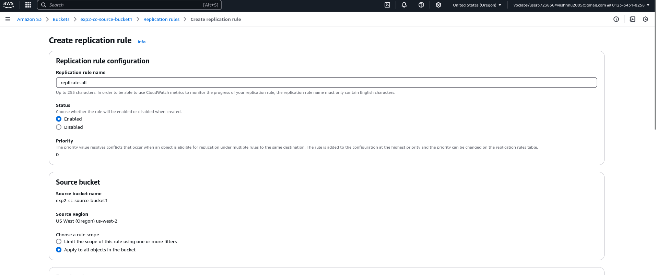

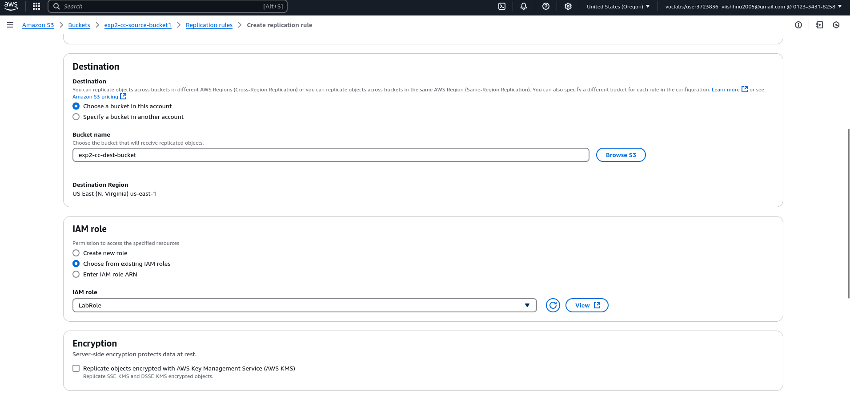

Click on Save

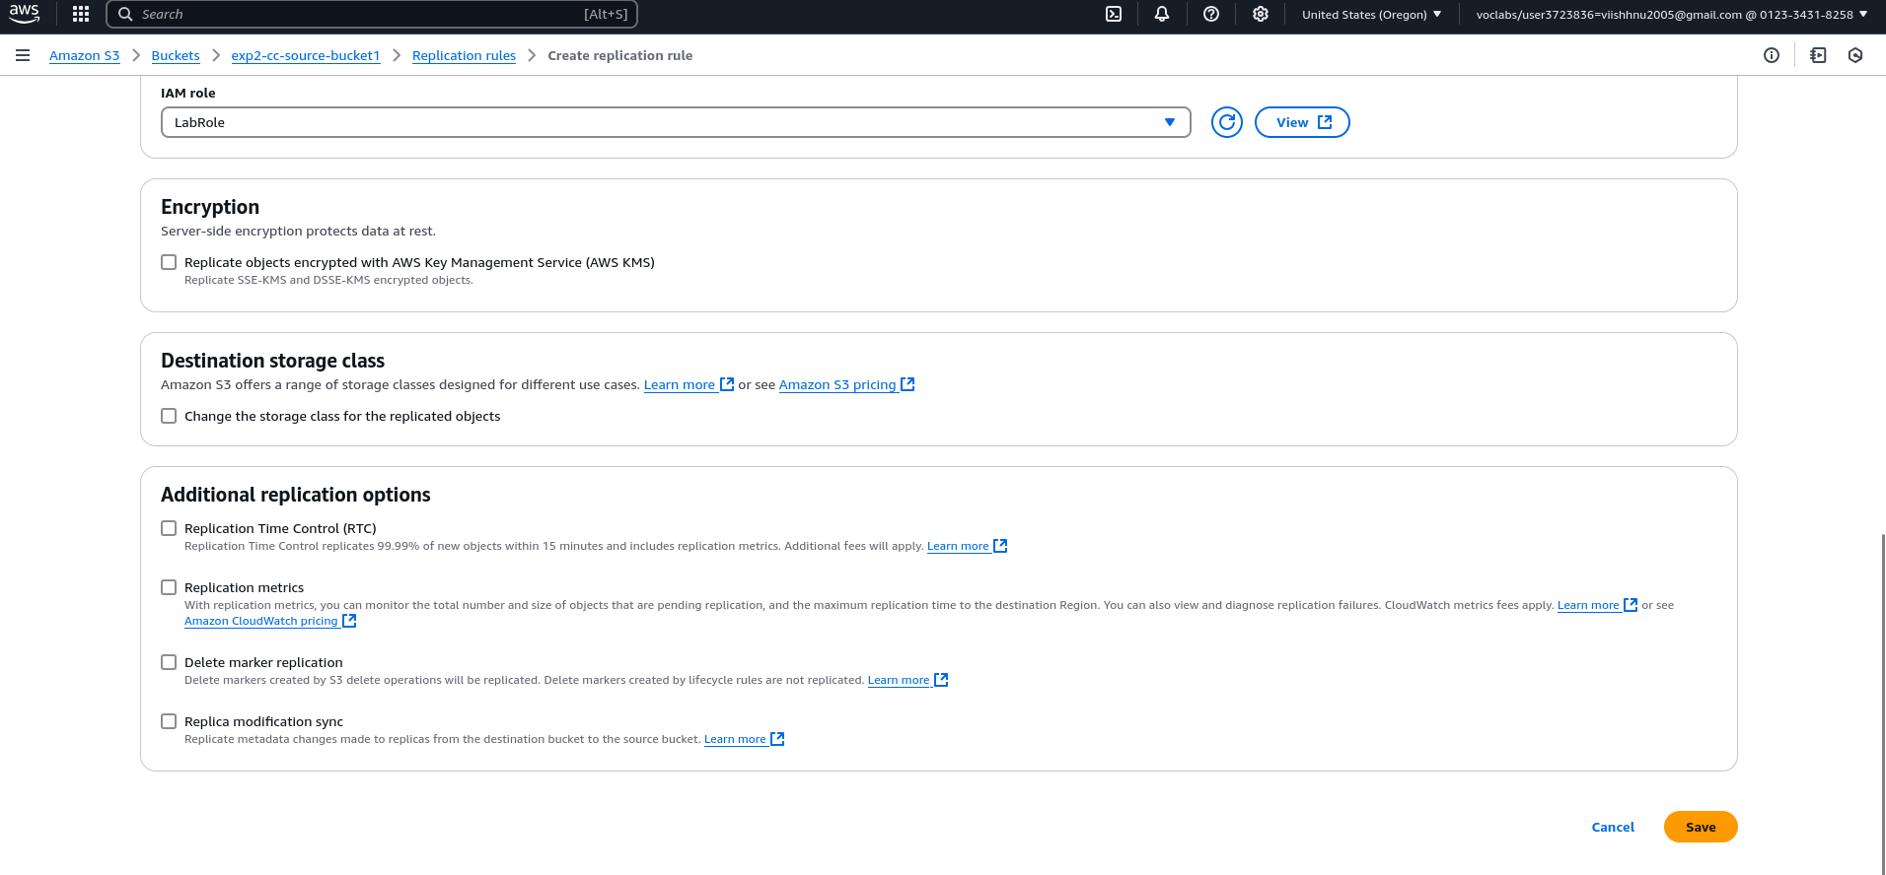

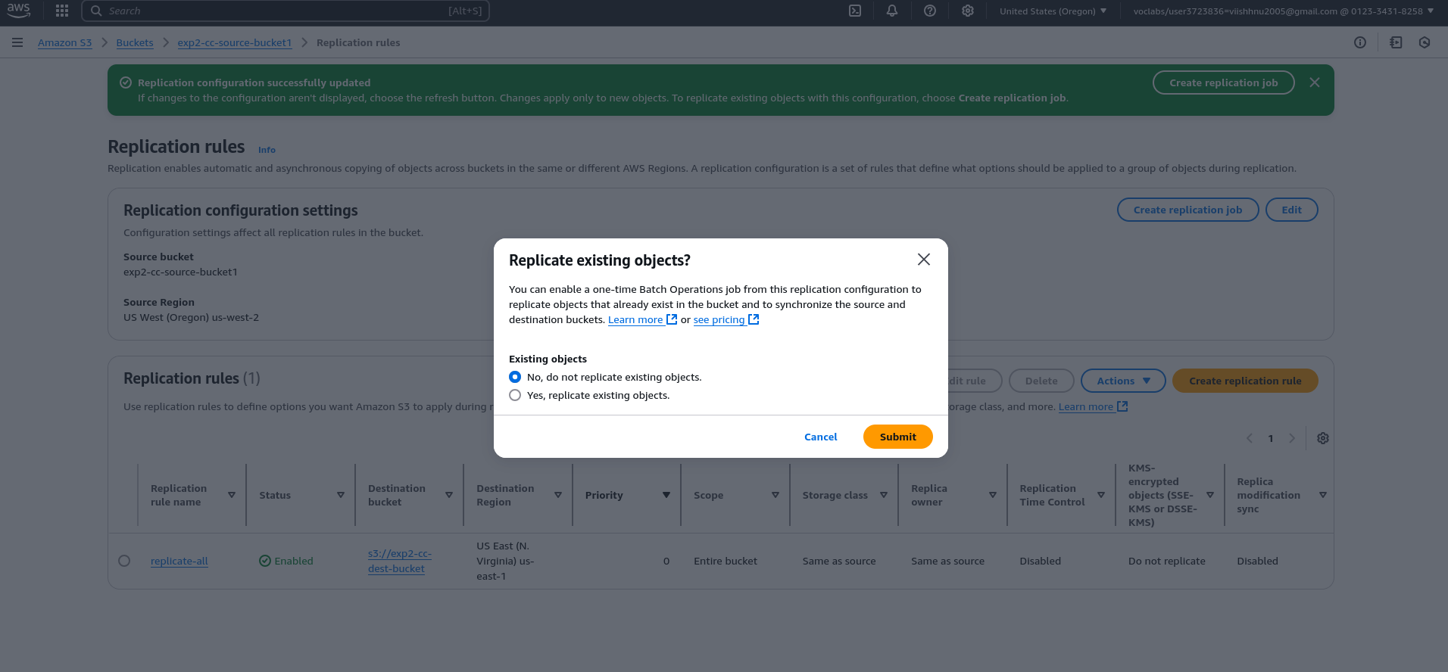

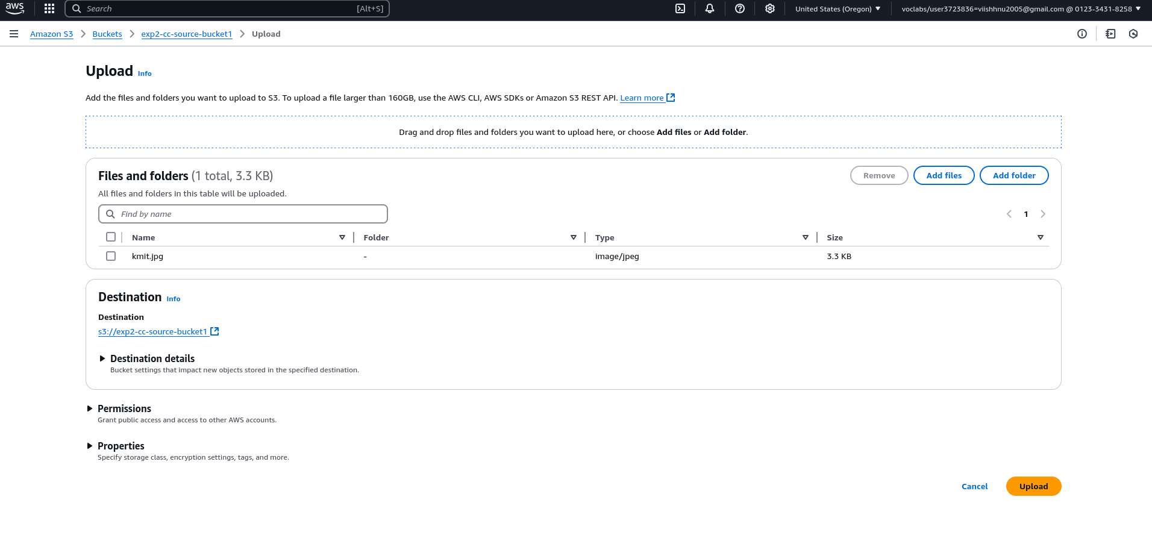

Now upload a object in source bucket it should display in destination bucket

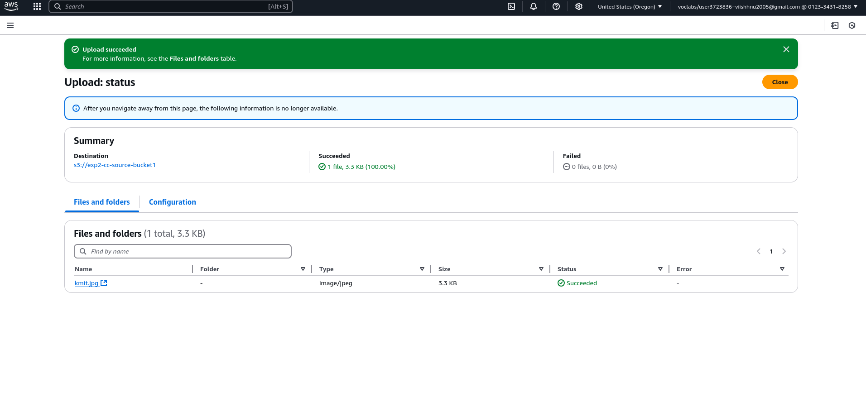 Now we got kmit.jpg in destination bucket

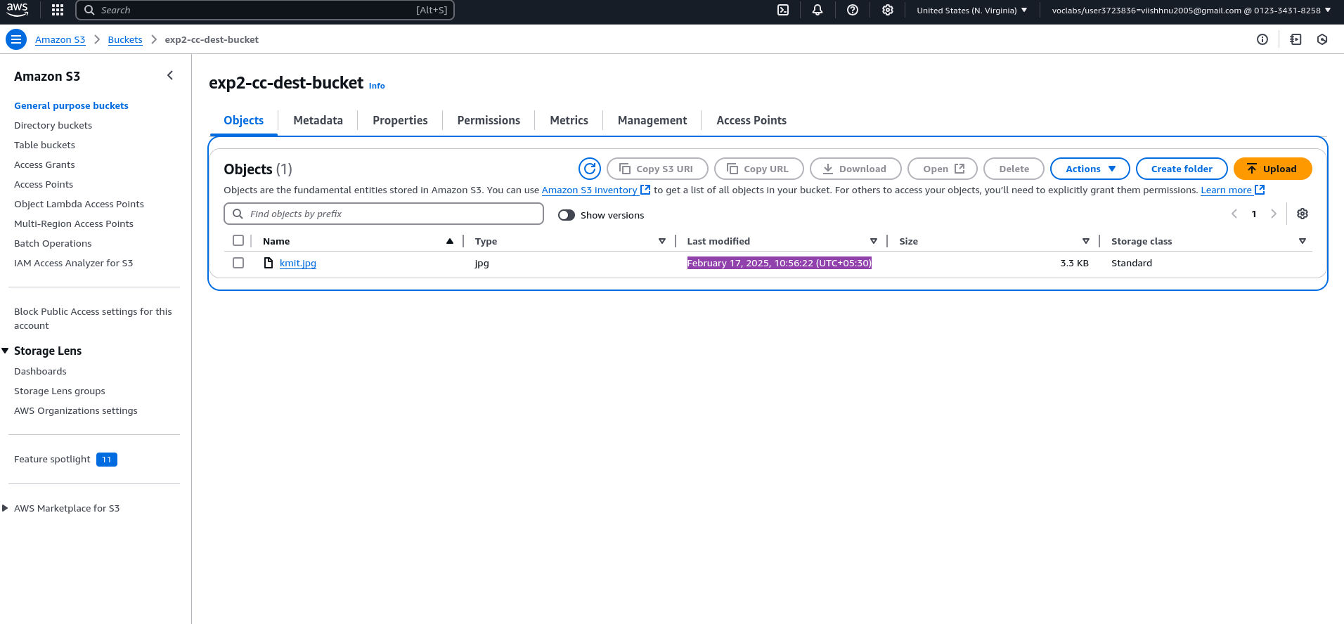

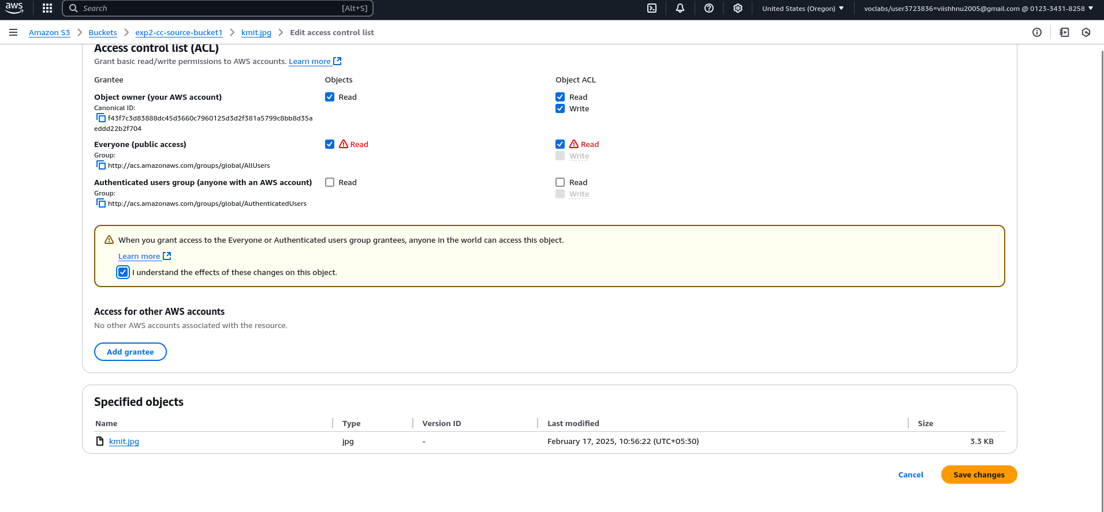Kmit logo:- [https://exp2-cc-dest-bucket.s3.us-east-1.amazonaws.com/kmit.jpg](../../../Downloads/word/theme/theme1.xml)

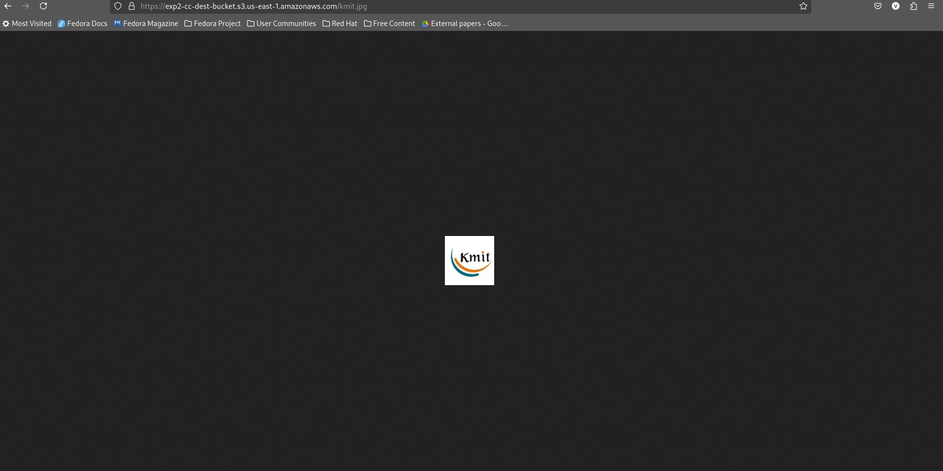

**Task-3 Usage of versioning of S3 Objects**

1) Create a bucket

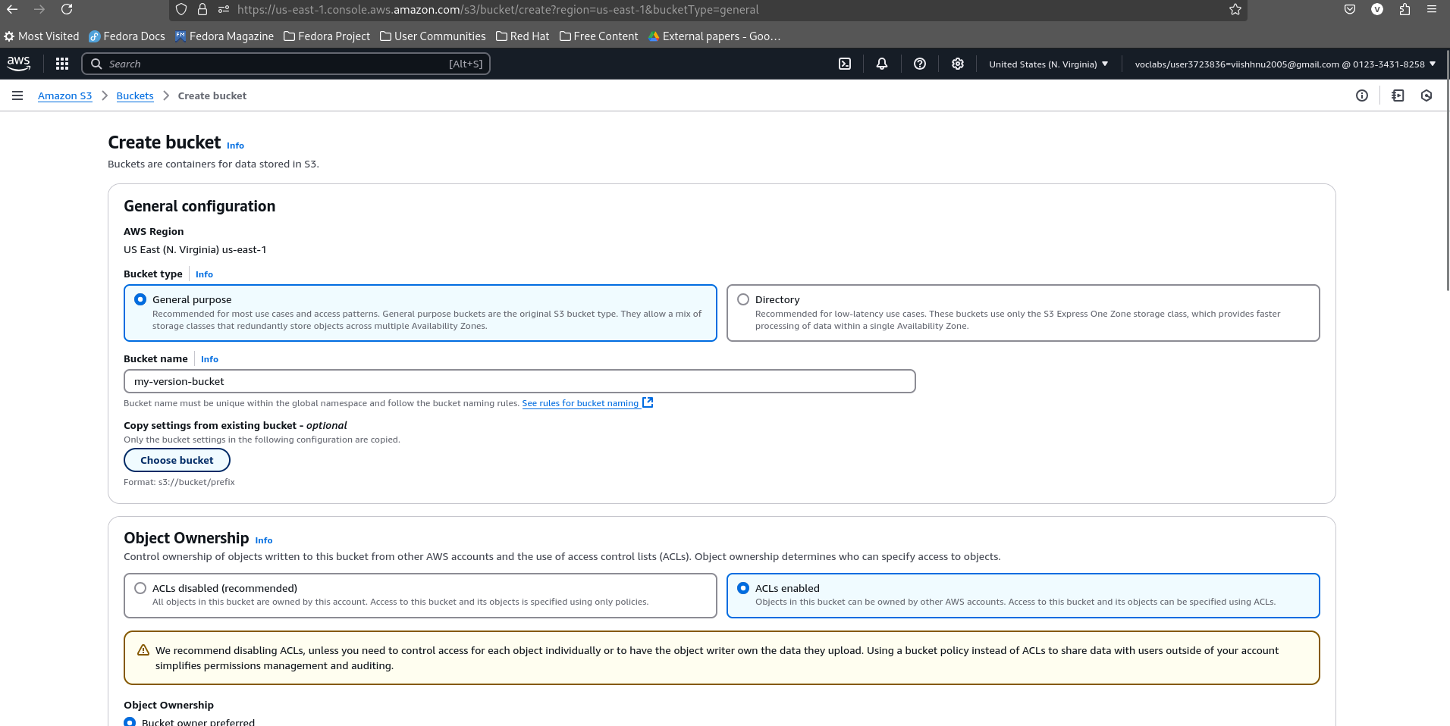

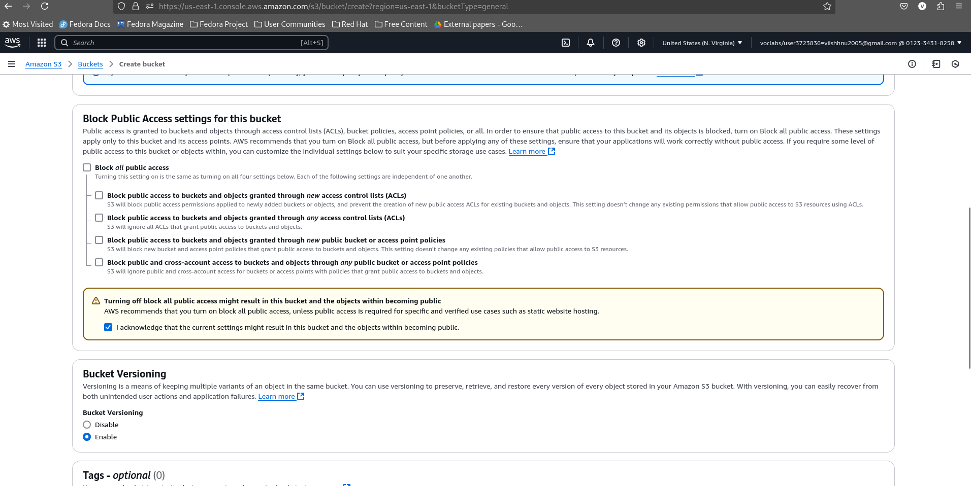

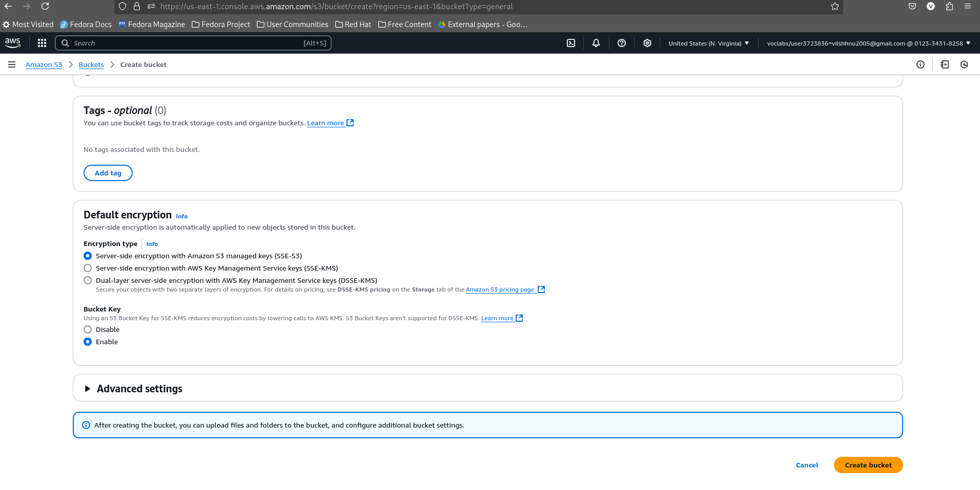

2) Upload a hello.txt

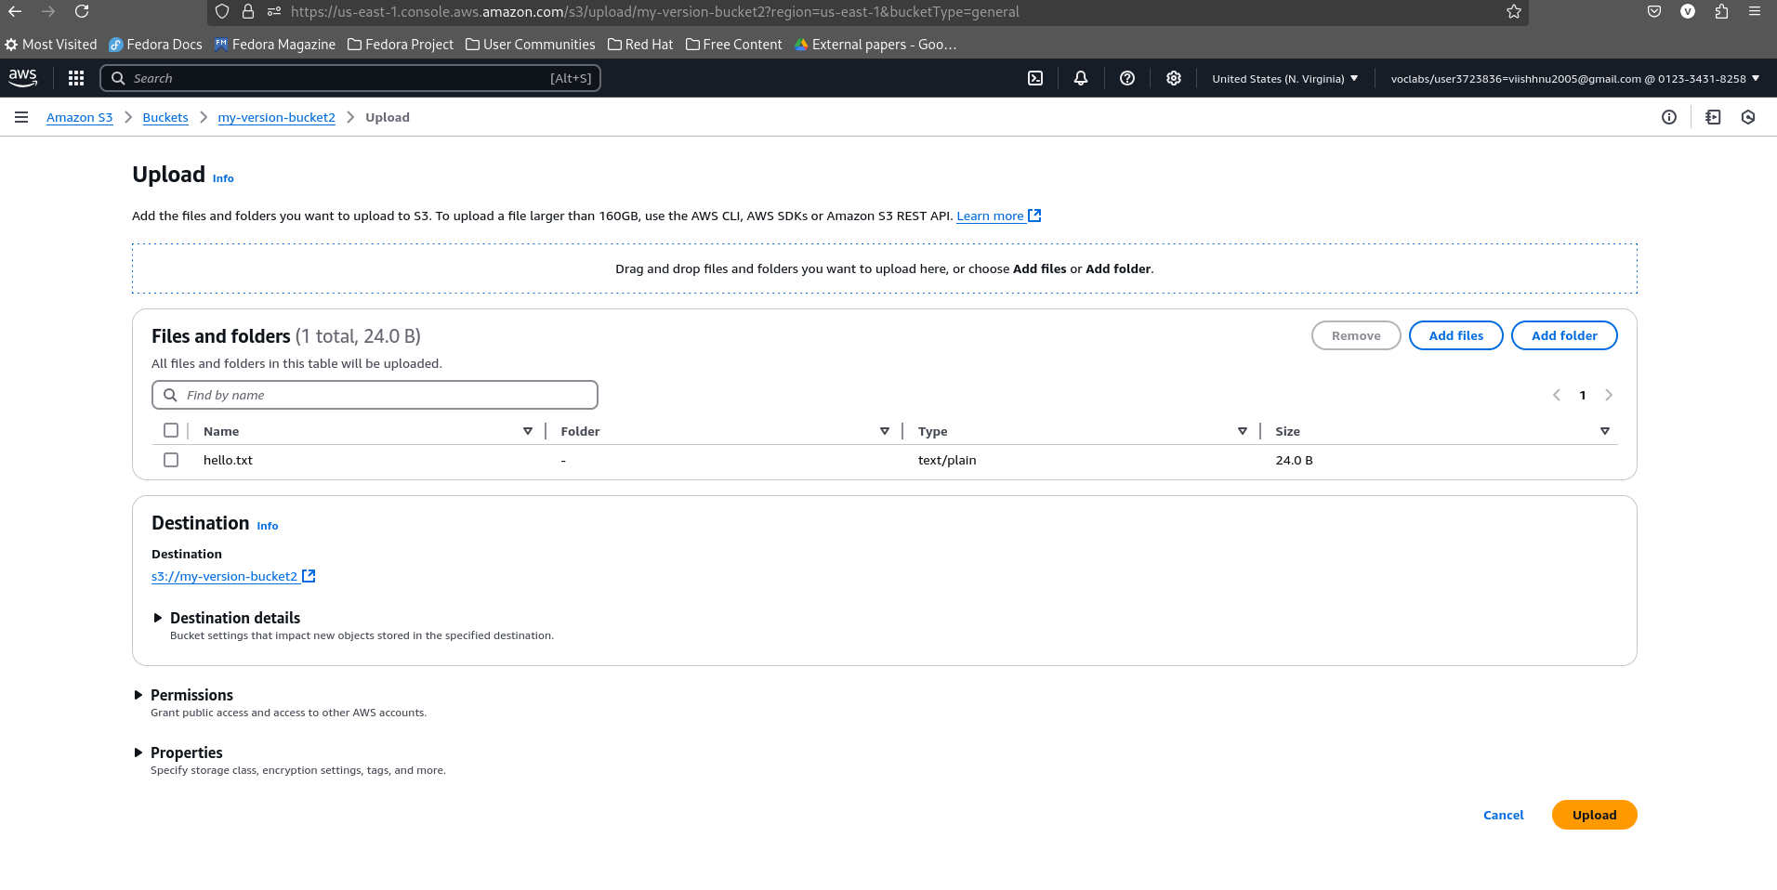

3) After I uploaded the same content again these are the versions avaialble

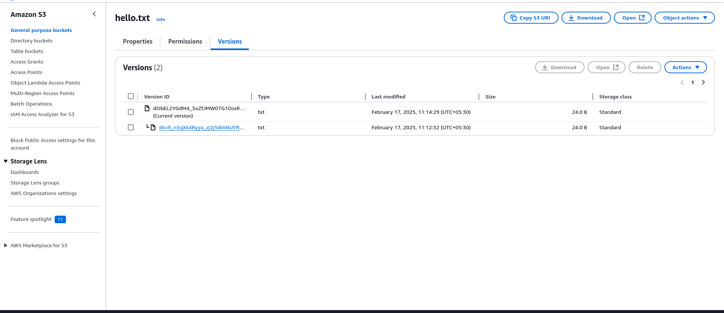

4.1) Delete a version

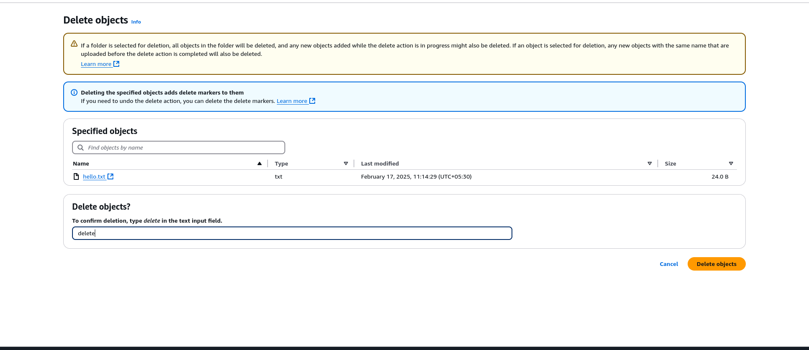

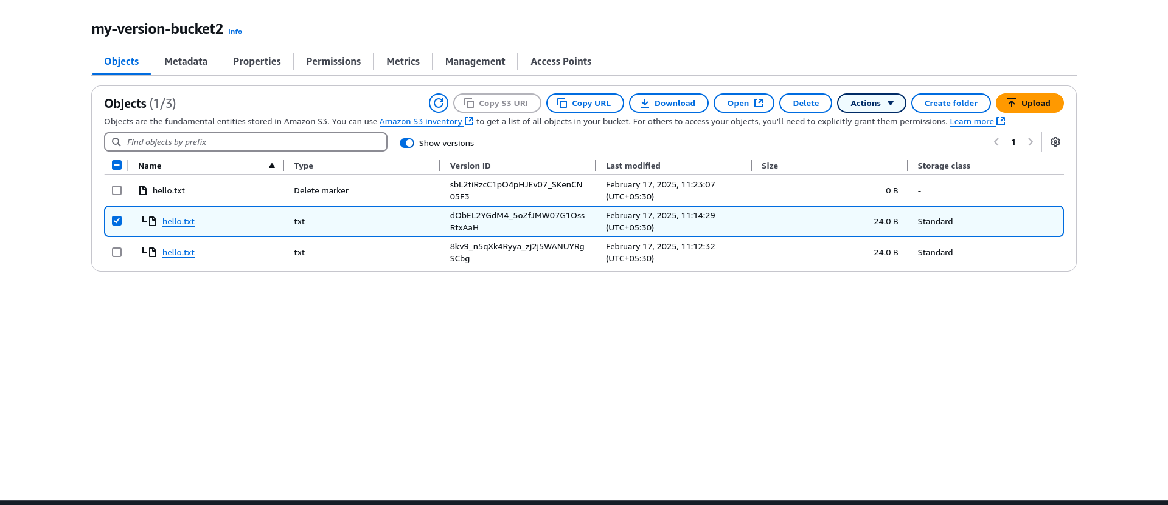

4.2) type permanently delete

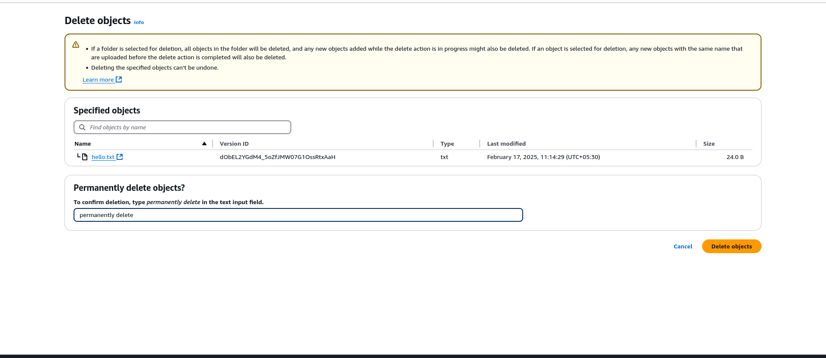

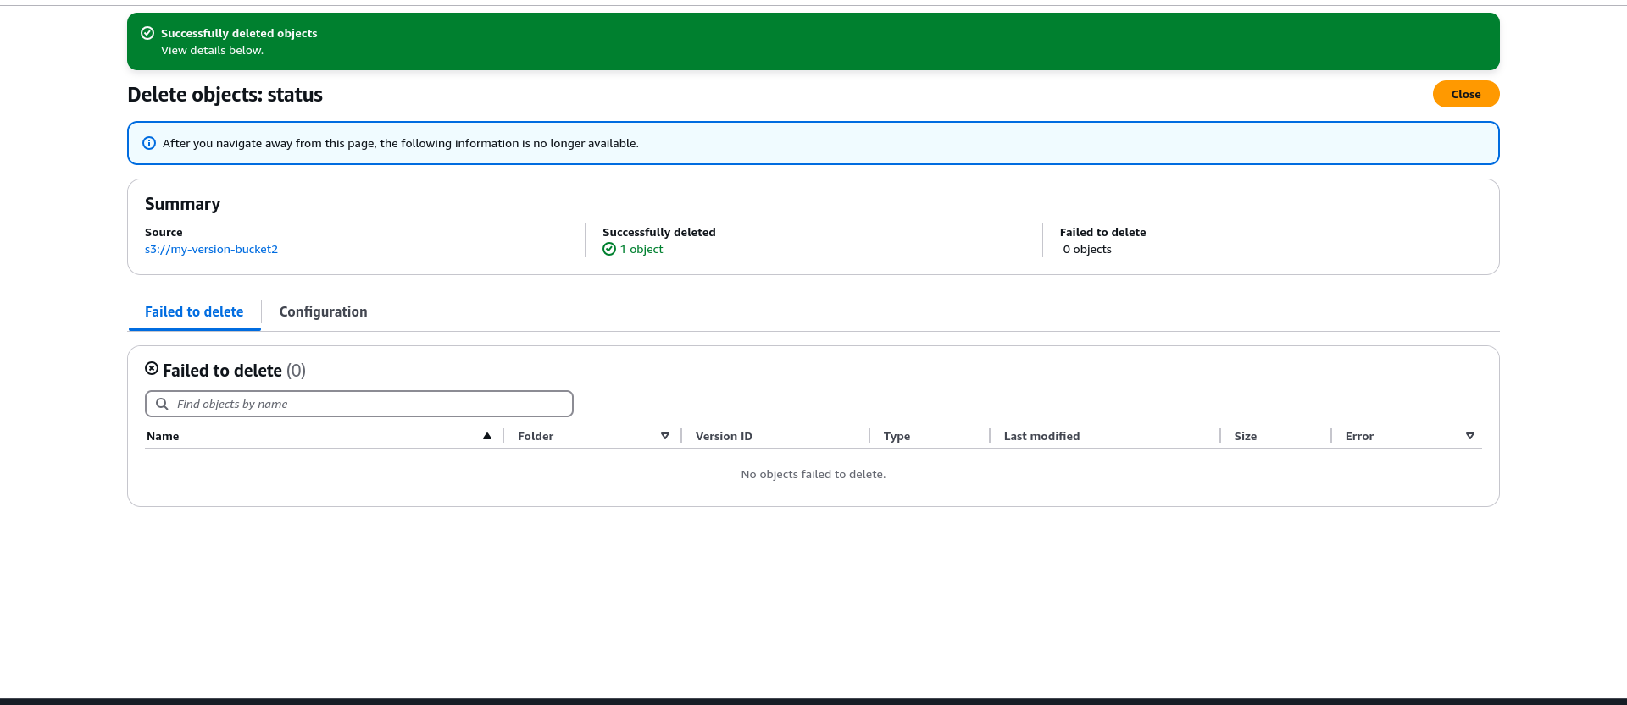5) Delete the object